

presents

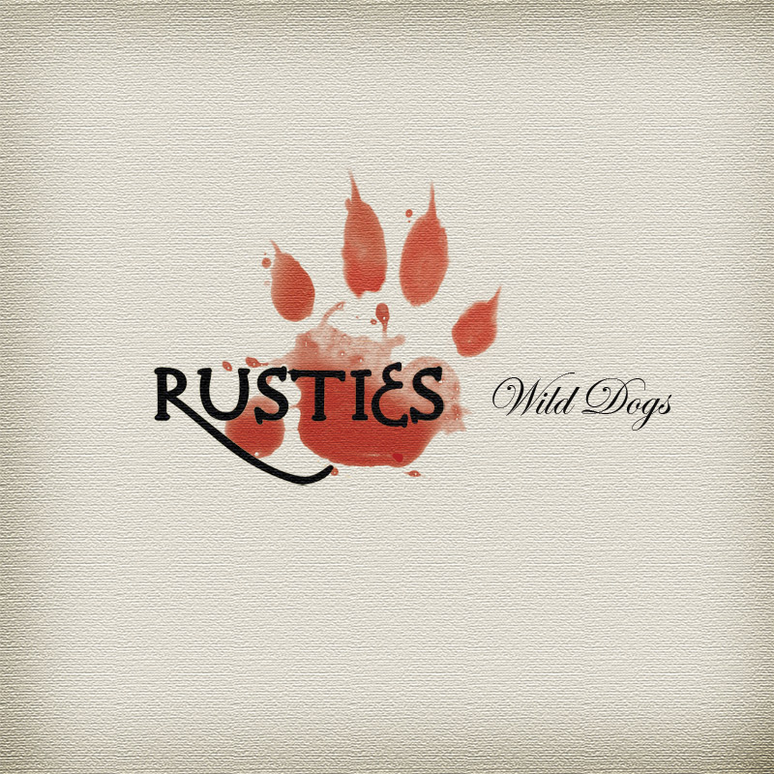

RUSTIES - “Wild Dogs”
(Tube Jam Records TJR 1101)

Release date: February 14th, 2011

Almost two years since the release of their first, acclaimed, album of originals Move Along, Rusties release their brand new album Wild Dogs on Tube Jam Records.

Wild Dogs will be out on February 14th 2011, featuring 9 original songs, 2 covers and featuring the amazing Irish voice of Mary Coughlan (lead vocalist on the title track and on Neil Young’s Razor Love) and Belfast singer/songwriter Andy White (co-authoring and co-producing three tracks).

For more than a decade Rusties has been an Italian rock band of experienced musicians dedicated to the music of legendary Canadian folk-rock icon Neil Young. Lead by rock critic, journalist, and writer Marco Grompi (lead vocalist, guitarist , main songwriter and author of several rock books and biographies, including Neil Young 1963-2003: 40 anni di rock imbizzarrito, hailed as the world’s most exhaustive Neil Young’s commented disco/biography), Rusties rocked some of the hippest clubs and festivals throughout Italy and Europe from their first concert in 1998 up to these days. Osvaldo Ardenghi (guitar & vocals), Massimo Piccinelli (keyboards), Dario Filippi (bass & vocals) and Paolo Guerini (drums) complete the current line up.

They began to perform individually as members of assorted Northern Italy club bands way back in the mist of times (actually some of them first jumped on a stage in the early 80’s!), and since 1998 they began performing together as a ferocious hippie rock quartet who basically loved to rock, enjoying wild and extended jam sessions and committing themselves to spread their “rusty” guitar improvisations over classic Neil & Crazy Horse repertoire. Their first rough demo, Rusties Never Sleep (recorded in a garage in a couple of hours in August 2002) raised so encouraging reviews that in November 2005 they decided to release Younger Than Neil, a self-produced CD of Neil Young songs recorded live in the studio to celebrate the rocker’s 60th birthday. Supported by a relentless concert activity in clubs, theatres and international festivals both albums quickly sold out and are currently out of print.

After hundreds of concerts throughout Italy (they shared stages, microphones and “on the road” experiences with Willard Grant Conspiracy, Gov’t Mule, Elliott Murphy, Dirk Hamilton, Steve Wynn, The Walkabouts, Fairport Convention, Lee Fardon, David Bromberg, Sarah Pierce, Andy White, Cristina Donà, Eileen Rose, Mary Coughlan and countless other international artists), in 2006 Rusties was the first Italian band to perform at the renown americana/folk rock festival Orange Blossom Special in Beverungen (Germany). Their highly acclaimed CD Live In Germany is a sonic snapshot of that smoking performance, and their loose, psychedelic version of CSNY’s Ohio (a strongly political song penned by Young in 1970) was included in the Rockpalast series double DVD Orange Blossom Special 10: It’s Your Universe (Glitterhouse Records) alongside performances by Steve Wynn, Broken Social Scene, Okkervil River, The Walkabouts, Jeb Loy Nichols, Seachange and many others.

In year 2008 Rusties celebrated their 10th anniversary with a slot of concerts and with the release of their fourth album Last Rust… The Best & The Rest, a limited edition collection of previously unreleased and rare live performances recorded over the past decade. They also spent some time in the studio, with assorted musical friends, recording their “new debut album” featuring only original songs.

Released in Summer 2009, Move Along (Tube Jam Records) is the Rusties first studio CD debuting ten self-penned and self-produced tracks. Immensely talented Italian singer/songwriter Cristina Donà guests on the mournful, melancholic title track, and experienced bluesman Robi Zonca adds his inspired guitar playing and backing vocals on a couple of other tracks. With its musical diversity, its wide range stylistic palette, its accurate production and the emotional depth of its song, the album didn’t fail to impress every good music lover. Since its release, Move Along raised amazing reviews all over the music press as “the most fascinating americana album produced by an Italian band ever” (Ibs.it). They’re constantly touring Italy and they already toured Germany four times, playing at festivals, clubs, and even appearing on national German TV NDR. In year 2010 Rusties also appeared on For You 2: A Tribute To Bruce Springsteen (Route 61 Records) with a mesmerizing rendition of Adam Raised A Cain and they performed in front of a crowd of 12,000 as the closing act of the 40th Anniversary edition of the legendary Fehmarn Open Air festival in Northern Europe.

Their second album of originals Wild Dogs (Tube Jam Records) is released to critical acclaim in early 2011. Amazing Irish jazz-blues singer Mary Coughlan guests on the passionate title track and on a poignant version of Neil Young’s Razor Love, and Belfast singer/songwriter Andy White shares writing and production credits on three tracks, including a song dedicated to the late Irish guitar hero Rory Gallagher. (…to be continued…)

RUSTIES:
Marco Grompi: vocals & guitars
Osvaldo Ardenghi: guitars & backing vocals
Massimo Piccinelli: keyboards
Dario Filippi: bass & backing vocals
Paolo Guerini: drums

Discography:
2002 – Rusties Never Sleep (FHG)
2005 – Younger Than Neil (FHG/IRD)
2007 – Live In Germany (FHG/IRD)
2008 – Last Rust… The Best & The Rest (FHG/IRD)
2009 – Move Along (Tube Jam)
2011 – Wild Dogs (Tube Jam)

www.rusties.it
www.myspace.com/rustiesband

Tube Jam Records Press Office:
Tel.: ++39 035 363180
Mob.: ++ 39 338 4019711
m.grumpy@tin.it

